Simulation Analysis of Weather-Driven Supply Chain Disruptions in a Dual-Line Automotive Assembly Plant
Author: Slade Gilmer
M.S. Candidate – Industrial & Systems Engineering
University of Alabama in Huntsville

Abstract
This study analyzes the resilience of a just-in-time (JIT) automotive assembly plant to weather-driven logistics disruptions using a stochastic simulation model. The simulated plant contains two assembly lines with different takt times and operates on a two-shift production schedule. Weather disruptions affecting directional supply corridors were modeled using seasonal probability distributions. Monte Carlo simulations were used to evaluate annual production losses, inventory resilience thresholds, and supply corridor vulnerabilities. Results indicate that directional supplier exposure significantly impacts disruption risk and that inventory buffers exhibit nonlinear resilience thresholds. Increasing buffer inventory beyond a critical threshold dramatically improves plant survival during supply chain interruptions.

1. Introduction
Modern automotive manufacturing relies heavily on just-in-time (JIT) supply chains to minimize inventory costs and improve operational efficiency. While effective under normal operating conditions, JIT systems can be vulnerable to external disruptions such as severe weather events that interrupt logistics networks.
Weather-driven disruptions have historically caused major manufacturing interruptions across the southeastern United States, particularly during large-scale severe weather outbreaks. The purpose of this study is to evaluate how such disruptions affect the resilience of a dual-line automotive assembly plant.
The primary research questions addressed in this study are:
- How frequently do weather disruptions impact production?
- Which supplier corridors present the greatest vulnerability?
- How much inventory buffer is required to sustain production during supply interruptions?
- How do logistics parameters such as truck frequency affect system resilience?

2. System Description
The simulated manufacturing system consists of two independent assembly lines operating in parallel.

Production Lines
Line | Manufacturer | Takt Time
Apollo | Toyota | 75 seconds
Discovery | Mazda | 78 seconds
Combined production capacity corresponds to approximately:
~701 vehicles per production day

Production Schedule
The plant operates a two-shift schedule, with each shift including scheduled breaks:
- 10-minute break
- 45-minute lunch
- 12-minute break
The facility operates approximately:
240 production days per year

3. Supply Chain Model
Parts are delivered via a truck-based just-in-time logistics system.

Logistics Parameters
Parameter | Value
Truck delivery interval | 180 minutes
Parts per delivery | 300
Initial inventory buffer | variable
Supplier locations are abstracted into four directional corridors.
Corridor | Description
North | Midwest / Nashville supplier routes
South | Alabama regional suppliers
East | Georgia supplier network
West | Mississippi / Arkansas supply routes
Storm disruptions affect corridors according to weighted probabilities reflecting regional weather patterns.

4. Weather Disruption Model
Weather disruptions were simulated using seasonal probability distributions.
Example seasonal distribution from simulation runs:
Season | Storm Events
Winter | 4
Spring | 5
Summer | 4
Fall | 0
Storm events temporarily block truck deliveries originating from the affected supply corridor.

5. Monte Carlo Simulation
Monte Carlo simulations were performed to evaluate disruption risk across multiple simulated years. Figure 1 below shows the distribution over 1,000 years.

Annual Production Loss
Scenario | Average Annual Loss
6-minute line stagger | 15,143 vehicles
No stagger | 15,108 vehicles
Worst simulated years showed losses exceeding 18,000 vehicles.
These results suggest that line staggering has minimal impact compared to logistics disruptions.
Figure 1
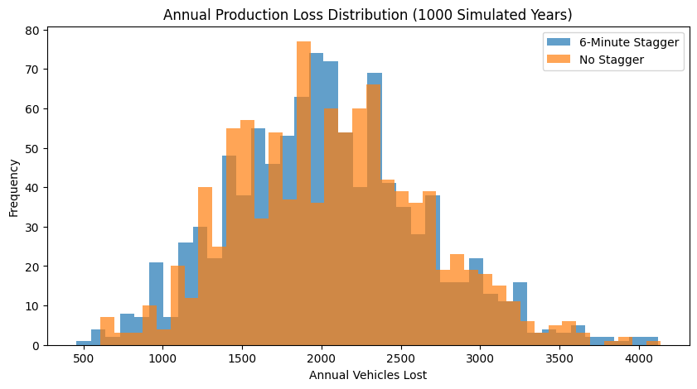

6. Supply Corridor Vulnerability
Directional analysis revealed uneven vulnerability across supplier corridors.
Average disruption losses by corridor:
Corridor | Relative Impact
North | highest
East | moderate
South | lower
West | lowest
This result reflects the greater exposure of northern supply routes to severe weather events. Figure 2 below shows the radar chart.

Figure 2
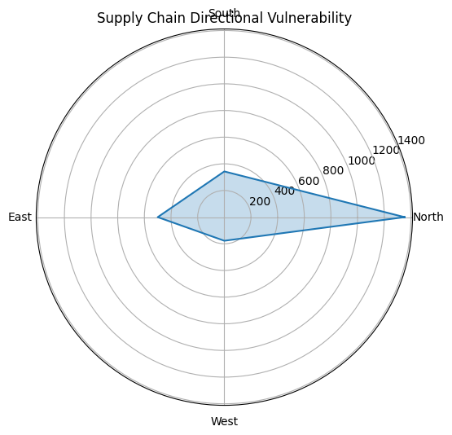

7. Inventory Buffer Resilience
The simulation evaluated plant survival time following a complete supply cutoff.

Inventory Buffer vs. Survival Time
Inventory Buffer | Survival Time
120 parts | 1.3 hours
180 parts | 1.9 hours
240 parts | 2.6 hours
300 parts | 3.2 hours
360 parts | 7.3 hours
420 parts | 7.9 hours
A resilience threshold occurs near 360 parts. Figure 3 below highlights the survival curve of the plant, particularly the jump in hours the plant can survive between the 300 and 360 parts buffer.
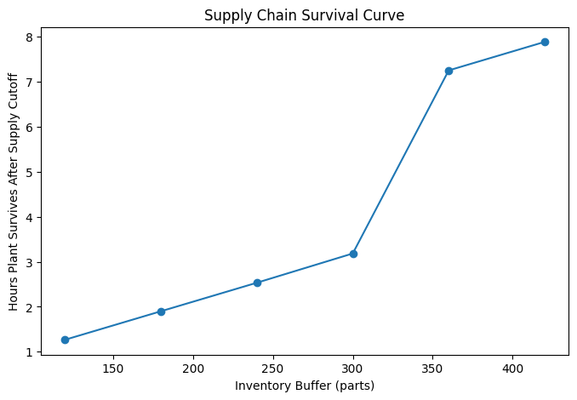
Below this threshold, the plant shuts down rapidly.
Above this threshold, the plant can survive an entire truck-cycle disruption.

8. Severe Weather Outbreak Scenario
A three-day severe weather outbreak scenario was simulated to evaluate cascading disruption effects.
Scenario timeline:
Day 1 – severe storms
Day 2 – tornado outbreak
Day 3 – logistics backlog recovery
Simulation results showed rapid inventory depletion followed by gradual recovery as deliveries resumed.

9. Supply Chain Resilience Heatmap
A parameter sweep evaluated the interaction between:
- truck delivery frequency
- inventory buffer levels
Results show three distinct operating regimes:
Region | Characteristics
Fragile | low buffer + slow deliveries
Operational | moderate resilience
Stable | high buffer or fast logistics
Crossing the buffer threshold significantly improves resilience. Figure 4 shows this (the darker the map, the better).
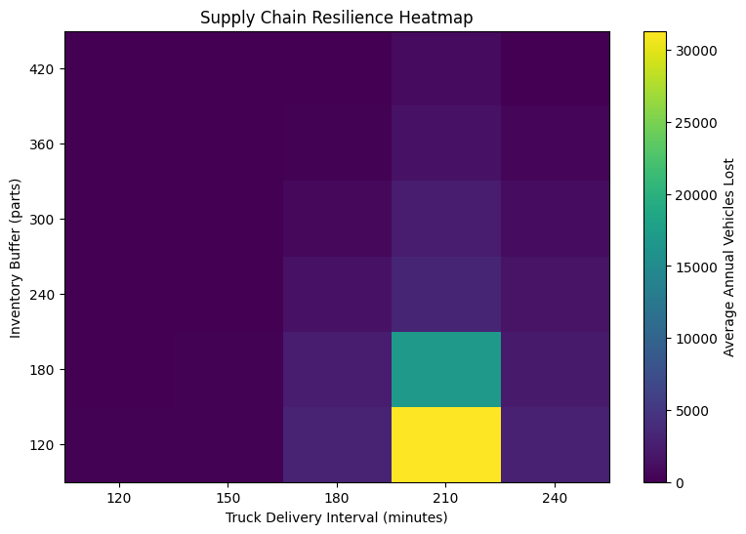

10. Discussion
The results highlight several characteristics of JIT manufacturing systems:
- Directional supply exposure significantly influences disruption risk.
- Inventory buffers exhibit nonlinear resilience thresholds.
- Logistics disruptions dominate over internal production factors such as line staggering.
These findings suggest that modest increases in inventory buffers can provide substantial improvements in resilience during severe weather events.

11. Conclusion
This study demonstrates that stochastic simulation can effectively model supply chain resilience in automotive manufacturing environments. The results indicate that weather disruptions can cause substantial production loss in JIT systems but that relatively small increases in inventory buffers can significantly improve operational stability.
Future research could integrate real meteorological data and supplier network models to further refine disruption forecasting.

12. Tools and Methods
The simulation model was implemented using:
- Python
- NumPy
- Matplotlib
- Google Colab
Outputs include:
- Monte Carlo disruption distributions
- resilience heatmaps
- survival curves
- directional vulnerability analysis

